LANGUAGE TRANSLATOR APP

# ADITYA BHAMBRE, NAYAN ZAGADE ,CHINMAY KALE

*Students, Department of Computer Engineering, D.Y Patil School OF Engineering &Technology, Pune Ambi, Maharashtra,India*

---------------------------------------------------------------------***---------------------------------------------------------------------

**Abstract -** *A language translator is an application that can be used to translate from one dialect to another. There have been difficulties in information communication between countries over the years. In modern times, language interpreters must understand and speak boththe language that is being translated and translated. The aim is to develop an android language converter app to make learning and language translation easy and facilitate stress-free communication, which can work more efficiently than other existing applicationswithanoptimized code for thetranslation process. The motto is to implement a lens for scanning the images instantly converting them to text and translating them. Making the app work even in offline mode is the main objective.*

***Key Words*: Language, Translation, Communication, Lens, Offline**

1. **INTRODUCTION**

A Translator is an assistant for translation that helps people survive in places where the language is unknown. They can easily input their message via text or speech and translate it into any language. This can also assist people with difficulty in writing with the help of speech recognition features. The text in an image canbe captured with a lens and it can be translated into any language as per the user's choice. I have used specific codes that process two or more combined user input modes, such as speech and image. Even for detecting the voice and for scanning images we used Java code to perform the actions, unlike other systems. In our proposed model itworks in both online and offline mode. The proposed model is the structure of the next generation of voice Assistants.

## LITERATURE SURVEY

This chapter will discuss an article review of our project. The article review is important because it is used to help the developer build the system so that the developer gets more knowledge of the pros and cons of the system, whichhelps the developer choose the best way to develop the system. Research and analysis of an existing system or current system have to be done to build a good system. A good system always comes after the enhancement of existing systems.

A Practical Guide for Translators, 5th ed, Bristol, Multilingual Matters by Samuelsson-Brown G in 2020 briefs about translators and their applications which helped to buildthe flow of developing the app effectively

Building a translation competence model by Amsterdam, John Benjamins in 2021 gave guidance on building the model

Triangulating Translation: Perspectives in Process Oriented Research by Amsterdam, John Benjamins in 2021 says about translation and its applications which helped in theimplementation of translation more efficiently

Approaches to Translation by Newmark P in 1981 tells how translation works efficiently and guided to complete the app successfully

The research helped in the completion of the applicationand served as a stepping stone for achieving efficiency in translation of text to text, speech-to-text, and text translation.

## PROBLEM STATEMENT

Communicating with people at one time when the user doesn't understand the language the other user speaks. By using this app, the user can easily understand whathe/she (another user) is speaking and translate it to the userwho uses the app. They are completely useful for the one who travels from country to country or from state

to state i.e. the one who travels the world. There are many apps like this but the app which has been developed can work completely in offline mode. Moreover, it can recognize the text in an image accurately and translate it to the language as per the user’s choice which reduces the efforts of the user in typing the text present in anything again in a translator app.

1. **REQUIREMENTS**

# Tools and Resources used –

* 1. Jupyter Notebook on Kaggle
  2. French to English Dataset
  3. Keras as the main library
  4. Pandas for pre-processing
  5. Natural Language Toolkit
  6. Matplotlib for graphical representations

### HARDWARE REQUIREMENTS

|  |  |  |
| --- | --- | --- |
| S.NO | REQUIREMENT | HARDWARE |
| 1 | Processor | Intel Pentium III |
| 2 | RAM | minimum 4 GB |
| 3 | HDD | 40 GB |
| 4 | Secondary Storage | 1.44 MB FDD, CD-R, CD+RW CD |
| 5 | Monitor | 14” Color Monitor |

* 1. **FUNCTIONAL REQUIREMENTS**
     1. System Admin: Installs translations in the application.
     2. Translator: Updates translations that can then be used in the application.
     3. Developer: Creates windows and customizations that use a translation

framework to enable a language-specific version of the customization.

* + 1. User: Works with the functionality in the application and specifies the language

they would like to view the user interface. Chooses a language from those that

are active within the application.

* + 1. **FLOW CHART**

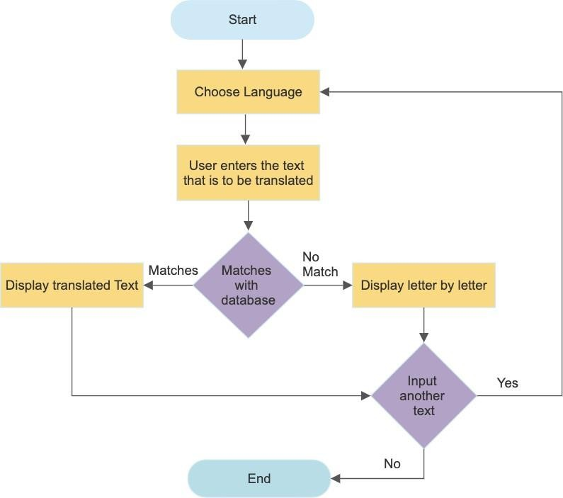

**Fig 1:** Flow of the application

## METHODOLOGY

6.1 **LSTM basic definition:**

Long Short-Term Memory (LSTM) is a type of

recurrent neural network (RNN) architecture designed

to overcome the limitations of standard RNNs in

capturing and retaining long-range dependencies in

sequential data. LSTMs are particularly well-suited for

tasks involving time series data, natural language

processing, and other sequential data analysis.

6.2 **RNNs and the Need for LSTMs:**

Standard RNNs process sequential data by

maintaining a hidden state that evolves as it receives

new input elements in a sequence. However, they suffer

from the "vanishing gradient" problem, which makes it

challenging for them to learn long-term dependencies.

This is because gradients that become too small during

backpropagation prevent earlier time steps from

effectively influencing later ones.

6.3 **LSTM Introduction:**

LSTMs were introduced to address this problem by

introducing a more complex structure within the

recurrent unit, which allows them to better capture and

propagate information across long sequences.

### 

## RESULT SCREENSHOTS

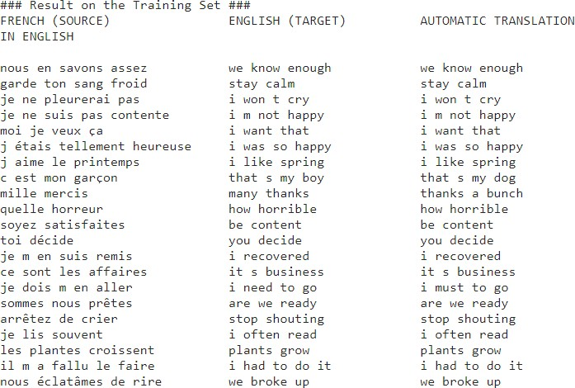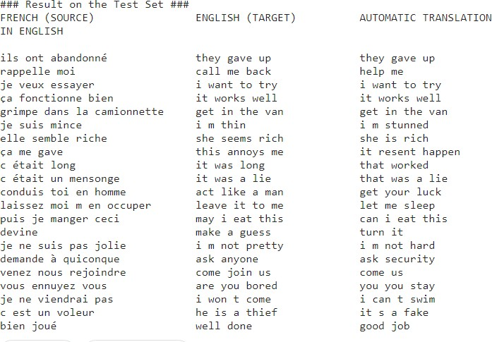

:

# Methodology for training

The methodology to process, train, and test the LSTM model is as follows –

1. Data Pre-processing – Here we use Pandas to perform pre-processing of the CSV file data i.e. they create the train and test sets for further use.
2. Create and train model – Here the Kera's and NLTK libraries for ML/AI are used to build and train the model. It includes models like LSTM, ‘corpus_belu’, Tokenizer, etc.
3. Result on test set – Towards the end a portion of the dataset will be used to test the model.
4. Prediction evaluation with BELU – Also BELU algorithm will be used to further investigate the accuracy of the LSTM model, here we use NLTK’s ‘corpus_belu’ method.
5. The result of the BELU score on training and test sets.
6. 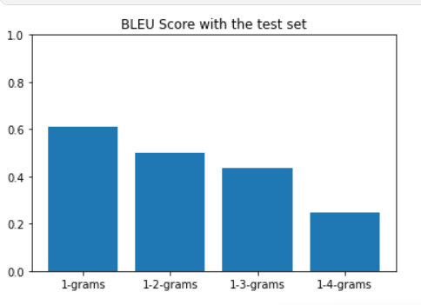Scientific World Journal Volume 2014 (2020), Article ID 267872
7. Md Gapar bin Md JoharFaculty of Information Sciences and Engineering, Management, and Science University, ShahAlam, Selangor Darul Ehsan, Malaysia(chapter-8)
8. Baker, M. (ed.) (2020) Routledge Encyclopedia of Translation Studies, London, Routledge.
9. Newmark, P. (1981) Approaches to Translation, Oxford, Pergamon.
10. Encyclopedia of Literary Translation into English by Olive Classe (Editor).

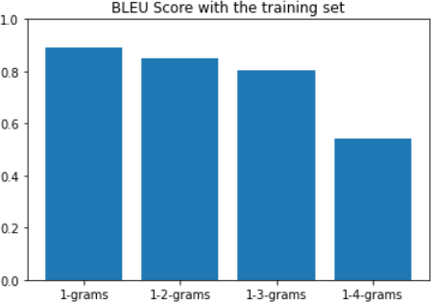

# Conclusion

* + - * + Deliver information in multiple languages
        + Improve communication in multiple languages
        + Increase human translation productivity
        + Create and manage enterprise language as a corporate asset
        + Integrate with enterprise application
        + Assist people with disability in speech
        + Capture images and translate them easily

Further future work can be taken up on language Recognition for text which is handwritten and also includes an option for uploading a document for translation

## REFERENCES

[1] 1Sim Liew Fong Faculty of Information Sciences and Engineering, Management and Science University, Shah Alam, Selangor Darul Ehsan, Malaysia(chapter 8)